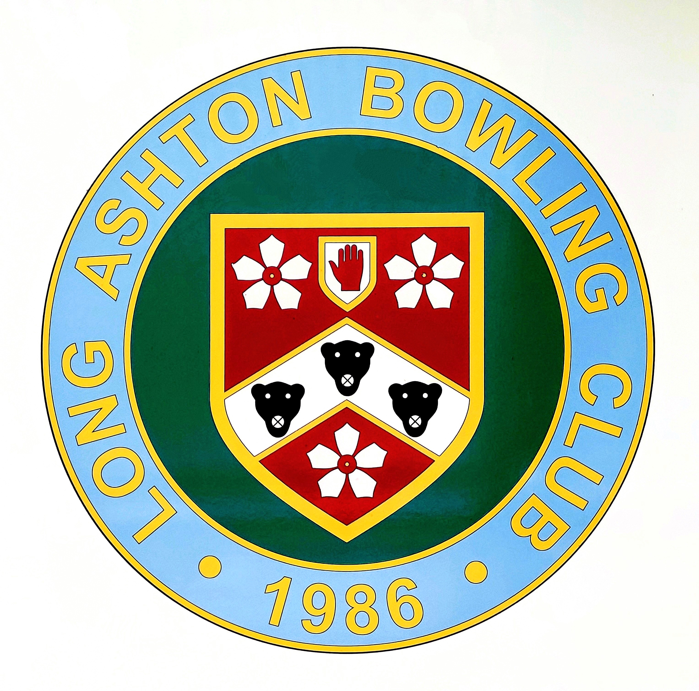

Coaching Tips and Good Practice

- Use a bowl that is comfortable in your hand. Hold the bowl upside down. If it feels comfortable, you have total control.

- Play with and against as many better players as you can. This will improve your game; observe how they adjust weight and line.

- When you practise, work on something specific; The Draw, The Drive, or Drawing to the Ditch.

- Win, lose, or draw, look at how you have improved your performance, whether that is, Mentally, Technically, or Tactically.

- Make sure you have time before every game to make sure you are 100% ready for the trial ends, to gain knowledge of the surface you are about to play on.

- Set yourself goals. Always have something to aim for.

- Be persistent, success doesn’t come easily.

- Watch every bowl, as you will learn something, regardless of whether it is good or bad. Remember, the mat is yours until the bowl comes to rest!

- Be patient, both on and off the green. Rome wasn’t built in a day!

- Try not to think about “what ifs”. Focus on the shot at hand.

- Anticipate your opponent’s approach, and plan for how you will respond.

- Make sure you are having fun! We all play this sport for the enjoyment it can bring, whether it is for social or competitive reasons. If you are starting not to enjoy your bowls, ask yourself why? Don’t be afraid to make changes.

- Respect your opponents and your own team members. We don’t intend to bowl a bad wood, but we all do!

- Finally, win or lose, finish every game with a smile and a handshake.

Enjoy your bowling!

